FedEx.com Ship Manager Registration Screenshots

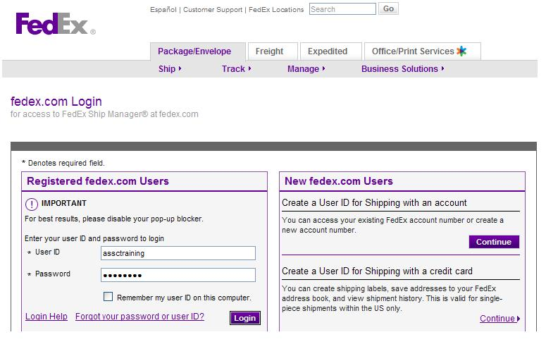

Login Screen

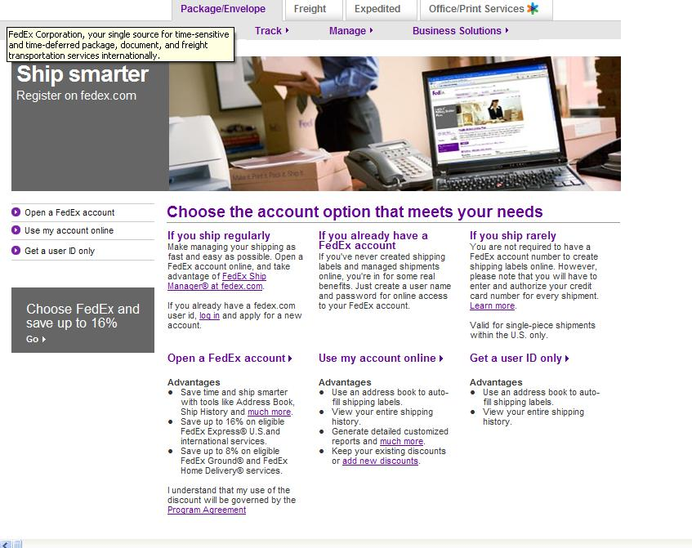

Screen 2

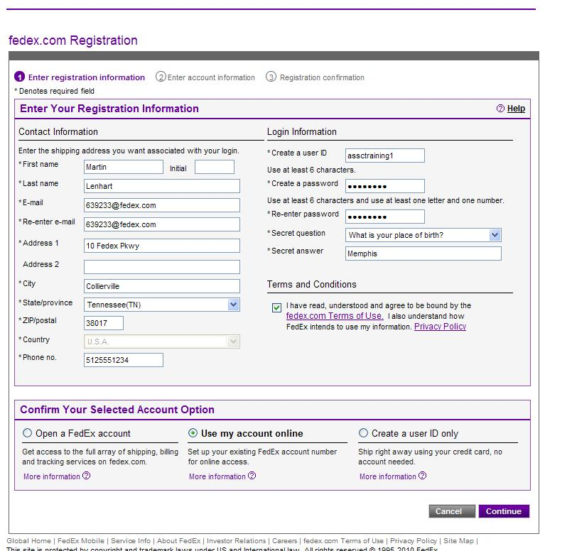

Screen 3 – Contact Info, User ID/Password, Security Question/Answer and Terms of Use

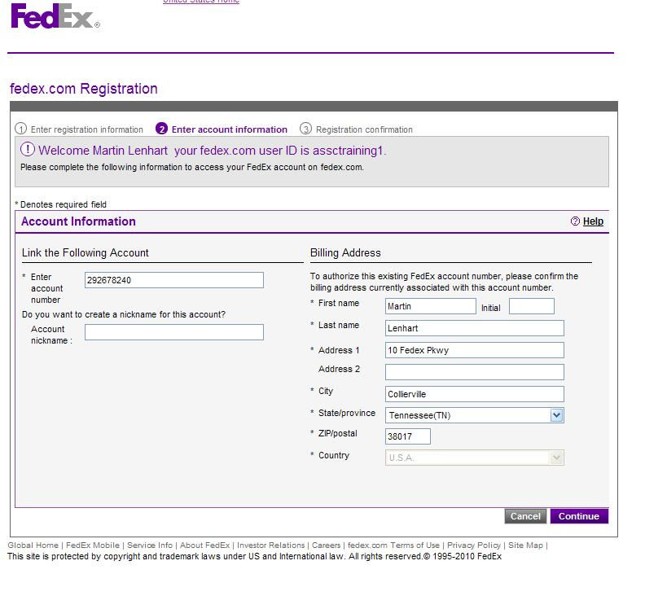

Screen 4 – Account # and Nickname – Verify Billing Address

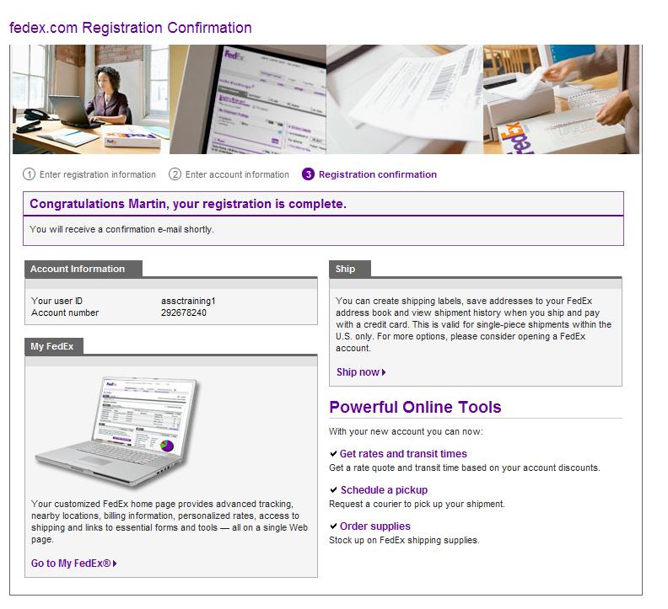

Screen 5 –Login Confirmation and “Ship Now”

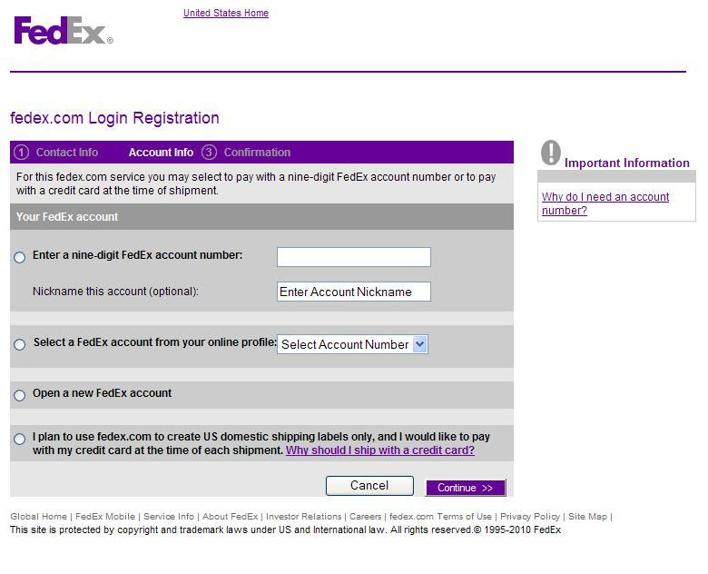

Screen 6 – Re-enter Account # / Nickname

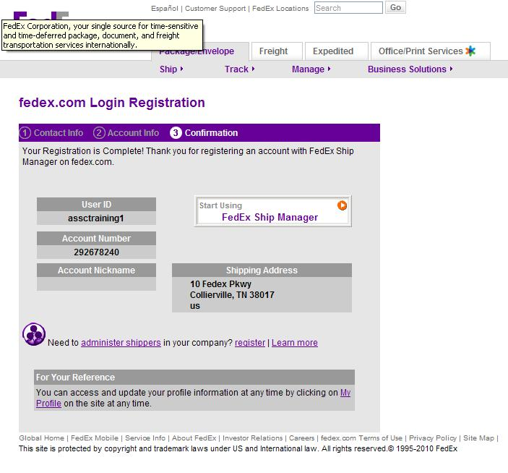

Screen 7 – final confirmation